CHRISTMAS IS BACK AS HYDE PARK WINTER WONDERLAND ANNOUNCES ITS 2021 RETURN

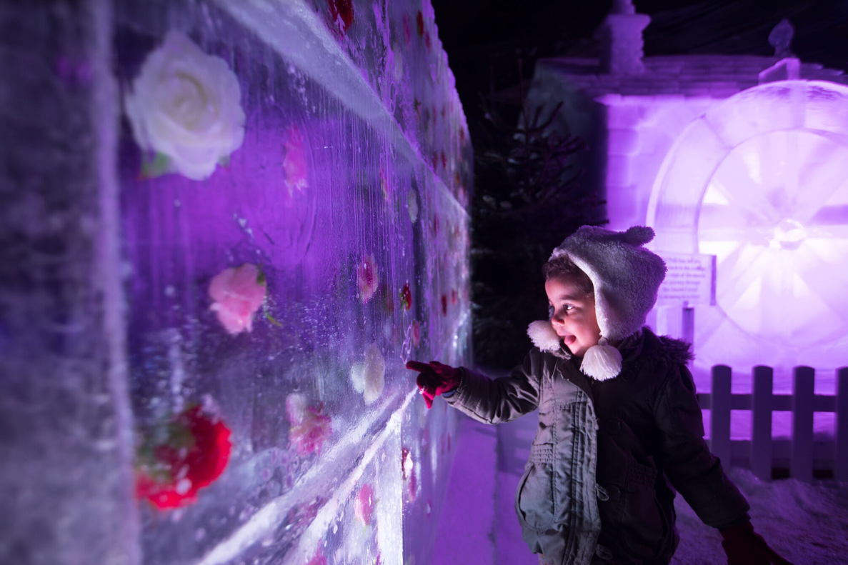

- The jewel in the crown of London’s festive calendar is back from 19 November 2021, with a magnificent array of more than 200 rides, attractions, games and food and drink offerings
- New measures introduced for enhanced guest comfort and safety, including timed entry tickets
- Secure your spot at the country’s most iconic festive celebration when the newly introduced entry tickets go on sale from 5 August

19 NOVEMBER 2021 – 3 JANUARY 2022
10.00am - 10.00pm
ATTRACTIONS INCLUDE:
UK’S LARGEST OUTDOOR ICE RINK
NEW MAGICAL ICE KINGDOM EXPERIENCE
NEW ‘70S DISCO-THEMED BAR ICE
NEW ZIPPOS CHRISTMAS CIRCUS & CIRQUE BERSERK SHOWS
ICE SCULPTING WORKSHOPS
NEW ALPINE-THEMED POP-UP RESTAURANT
GIANT WHEEL (70M WHEEL)

July 2021, London: The UK’s most iconic festive event will be making its grand return this Christmas. After a one-year hiatus and difficult Christmas for many in 2020, this year friends and family can finally get together and ring in the season at London’s Hyde Park Winter Wonderland starting 19 November 2021.

Open daily from 10.00am – 10.00pm, Hyde Park Winter Wonderland is bringing back Christmas with a wondrous list of attractions, new themes and returning favourites including the UK’s largest outdoor Ice Rink, new Magical Ice Kingdom and Bar Ice experiences, new Zippos Christmas Circus and Cirque Berserk shows, the Giant Wheel, and more.

To safely deliver the magical, inclusive festive experience people know and love, Hyde Park Winter Wonderland is introducing several new measures. To ensure the safety and comfort of visitors, the event is introducing timed entry tickets which will help to manage guest numbers. The ticket system, similar to other Christmas destinations around the world, is designed to enhance the guest experience, providing visitors with more space and ensuring more time is spent on much-needed festive fun for as long as they want until closing at 10pm.

“We’re so excited to be bringing the UK’s largest festive event back this Christmas after a difficult 18 months for all and a lonely Christmas for many in 2020,” said Suzy Griffiths, Hyde Park Winter Wonderland’s Event Director. “Importantly, the changes we’re making this year, including reducing capacity and introducing timed entry tickets, will help us deliver the same magical experience our visitors love in a way that prioritises everyone’s comfort and safety and allows us to adapt to new requirements if needed.”

“We can’t wait to welcome everyone back for some much-needed festive fun at Hyde Park Winter Wonderland, with more than 200 rides, attractions, shows, games and incredible food and drink options!”

Alun Mainwaring, Head of Events, Filming and Commercial Development at The Royal Parks, said: “We are delighted to be back hosting events in the heart of London and are excited to showcase our new ticketed Hyde Park Winter Wonderland. The comfort and safety of our visitors is a priority and in this new world our ticketing system means we can open safely allowing visitors to plan their day and timed entry slot.”

For those looking to get a head start on their festive plans and lock in the city’s most magical Christmas experience, tickets and pre-bookable attractions are on sale starting 5 August 2021. The event will be offering off-peak (free), standard (£5), and peak (£7.50) timed entry tickets to help manage the flow of the event during periods of higher and lower demand, with a number of mid-week morning entry tickets available to book for free. However, visitors who spend £20 on attractions, rides, food, drinks or games in advance of their visit will receive a free entrance ticket when booked in the same transaction.

The Magical Ice Kingdom returns for 2021 with a new theme and the ultimate festive immersive experience. Visitors will be taken on a journey through a magical fantasy and mythical world, as they enter a palace to see forest glades, dazzling lights and enchanting connecting tunnels into different lands. Visitors will be transported into a world of sorcerers, throne rooms, dragons, snow slides and panoramic views.

The UK’s largest and most enchanting open-air ice rink is of course back for this year’s Hyde Park Winter Wonderland. Nestled in the heart of the capital’s favourite park and surrounding the ornate, Victorian bandstand, it’s the ultimate ice-skating experience to be had in the heart of London. Unwind and glide across the ice as the bandstand singer provides a festive musical backdrop under the canopy of sparkling lights. Penguin skating aids are available to support the little ones and for the less experienced, ice guides can be hired, with spectators able to watch from the viewing gallery.

Those looking to enter the party season in style can escape to Hyde Park Winter Wonderland’s Bar Ice where they can expect to live it up in true ‘70s Disco fashion. Inspired by New York’s iconic disco era, the experience is surrounded by sequins, glitter balls and beautifully carved ice sculptures, with the bar, tables, chairs, and even glasses all made of ice! Each ticket includes a complimentary cocktail, and a cloak to survive -10C temperatures, with an extended shots list of Bar Ice classics.

Continuing the festive party vibes, The Fire Pit will host music sets from DJs and musicians from the capital, with the exclusive Explorers Rest also boasting the ultimate live music experience, perfect for larger groups looking for a festive work night-out or gathering with friends and family. Throughout the event, there’ll be delicious street food and winter classics to tuck into, as well as Jimmy Garcia’s new Alpine themed pop-up restaurant serving tasty street food including the legendary raclette burger, venison hot dogs and truffle and parmesan fries.

Returning with an all new seasonally themed show, Zippos Christmas Circus won’t fail to thrill and delight the whole family. With jaw-dropping aerial acrobatics and laugh-out-loud clowning, this feelgood show is fun-packed and fast-paced from start to finish. At under an hour, it’s the perfect length for families and has a buggy park for younger children.

Continuing the circus theme, Cirque Berserk and its international troupe of brave daredevils, aerialists and acrobats have raised the stakes with a new show packed with off-the-chart thrills and mind-blowing stunts. Back by popular demand, The Globe of Death returns with its motorcyclists reaching speeds of 60mph as they hurtle around the giant steel cage. It’s a fast paced, full throttle thrill like no other.

2021 also welcomes back the hugely popular Ice Sculpting Workshops. Visitors are invited to pick up an ice chisel (and a brand-new skill!) as they learn from the UK’s finest ice artists who design and create the Magical Ice Kingdom. Hosted in the bespoke sculpting studio, each workshop will be available via pre-booking only, and includes free entry into the Magical Ice Kingdom.

Get Christmas 2021 in the calendar with tickets available to purchase starting 5 August from hydeparkwinterwonderland.com.
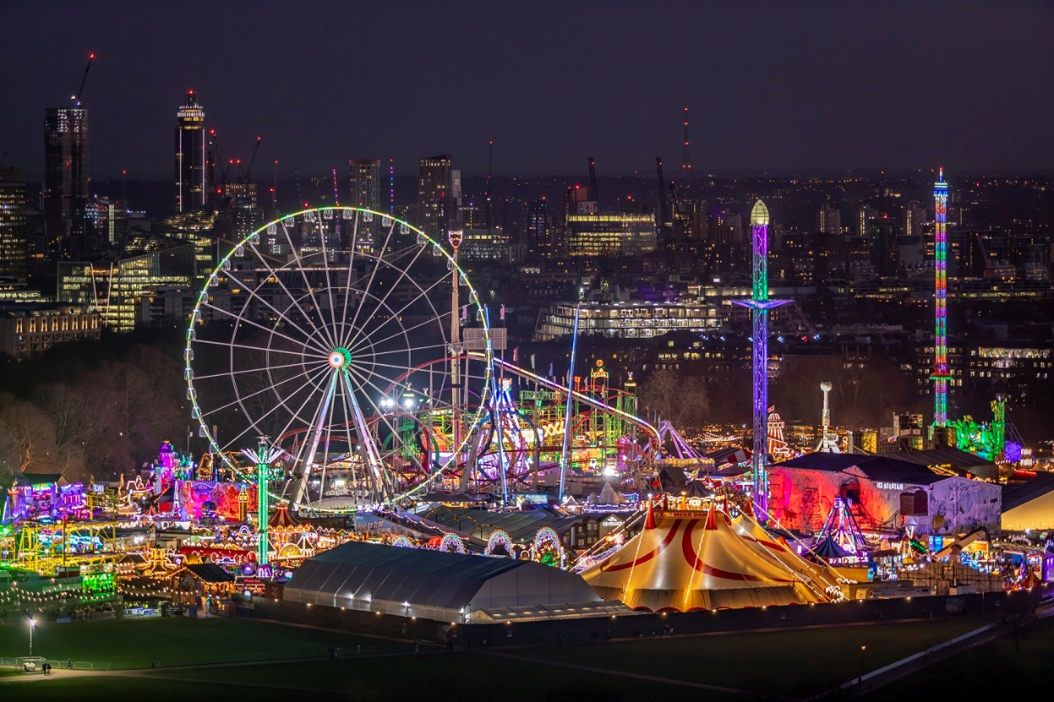

Notes to Editor

For more information please email: winterwonderland@wcommunications.co.uk or call 07976091109

Images found here https://drive.google.com/drive/u/0/folders/12Kj5AgAhsdLLdUIyn7lgUtOgih8q9q-7

Key dates
Press preview night: Thursday 18 November 5.00pm – 10.00pm

Onwards: Friday 18 November - Monday 3 January, 10.00am – 10.00pm (open every day except closed on Christmas Day)

To ensure the safest and most entertaining experience is had by all, all Hyde Park Winter Wonderland visitors will require a timed entry ticket. Guests will be able to enter Hyde Park Winter Wonderland for free during off-peak times. Standard tickets will be priced at £5.00, peak tickets will be priced at £7.50. The event will have three entry times:
- Morning entry times – 10am – 1pm
- Afternoon entry times – 1pm – 5pm
- Evening entry times – 5pm – 10pm (last entry 9:30pm)

About IMG

IMG is a global leader in sports, fashion, events and media. The company manages some of the world’s greatest athletes and fashion icons; owns and operates hundreds of live events annually; and is a leading independent producer and distributor of sports and entertainment media. IMG also specializes in licensing, sports training and league development. IMG is a subsidiary of Endeavor, a global entertainment, sports and content company.

Notes to editors:
For further information please visit: www.royalparks.org.uk.
For media enquiries contact: 0300 061 2128 or press@royalparks.org.uk
About The Royal Parks
The Royal Parks is the charity that exists to make sure London’s eight historic royal parks will always be there to enrich the lives of local residents and visitors to London.
The charity looks after eight of London’s largest open spaces: Hyde Park, The Green Park, Richmond Park, Greenwich Park, St James’s Park, Bushy Park, The Regent’s Park and Primrose Hill, and Kensington Gardens.
Follow The Royal Parks on Twitter @theroyalparks, Facebook.com/TheRoyalParksLondon and Instagram.com/TheRoyalParks

