September brought a touch of excitiment for the Forum, with news we had made the shortlist for the National Diversity awards. It was a record breaking year with 75,000 people being nominated. 126 nominees made the short list in being recongnised for their various achievements nationwide. SGTCF were one of eight groups that made it into the shortlist, in the category of Community Organisation Award, Race, Religion & Faith. Although we didn’t win, it was so important to have recognition. It was a fantastic event, mixed with celebraties, champange and excellent food. Two of our SGTCF members attended and had a wonderful evening, meeting some inspirational indivduals and groups, all set in the beautiful surroundings of Liverpool Cathedral. Then followed a fantastic after party and a Kushti gift bag full of treats.
  - Volume 1 | Issue 2
December 2022 Newsletter
Christmas Edition

The National Diversity Awards 16th September 2022
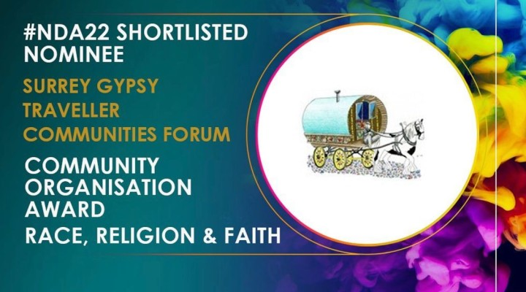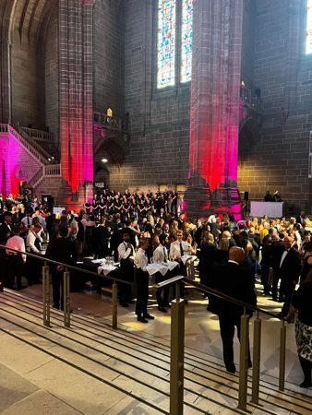
Thank you to all that voted for us, and a big thank you to the National Diversity Awards 2022 for a wonderful evening!

THE PEOPLE OF WARDLEY STREET
The blue Plaque Reads
for over one hundred years The People of Wardley Street and neighbouring roads in Wandsworth were home to people of Romany Gypsy & Traveller Heritage, many of whom worked as costermongers and flower sellers.
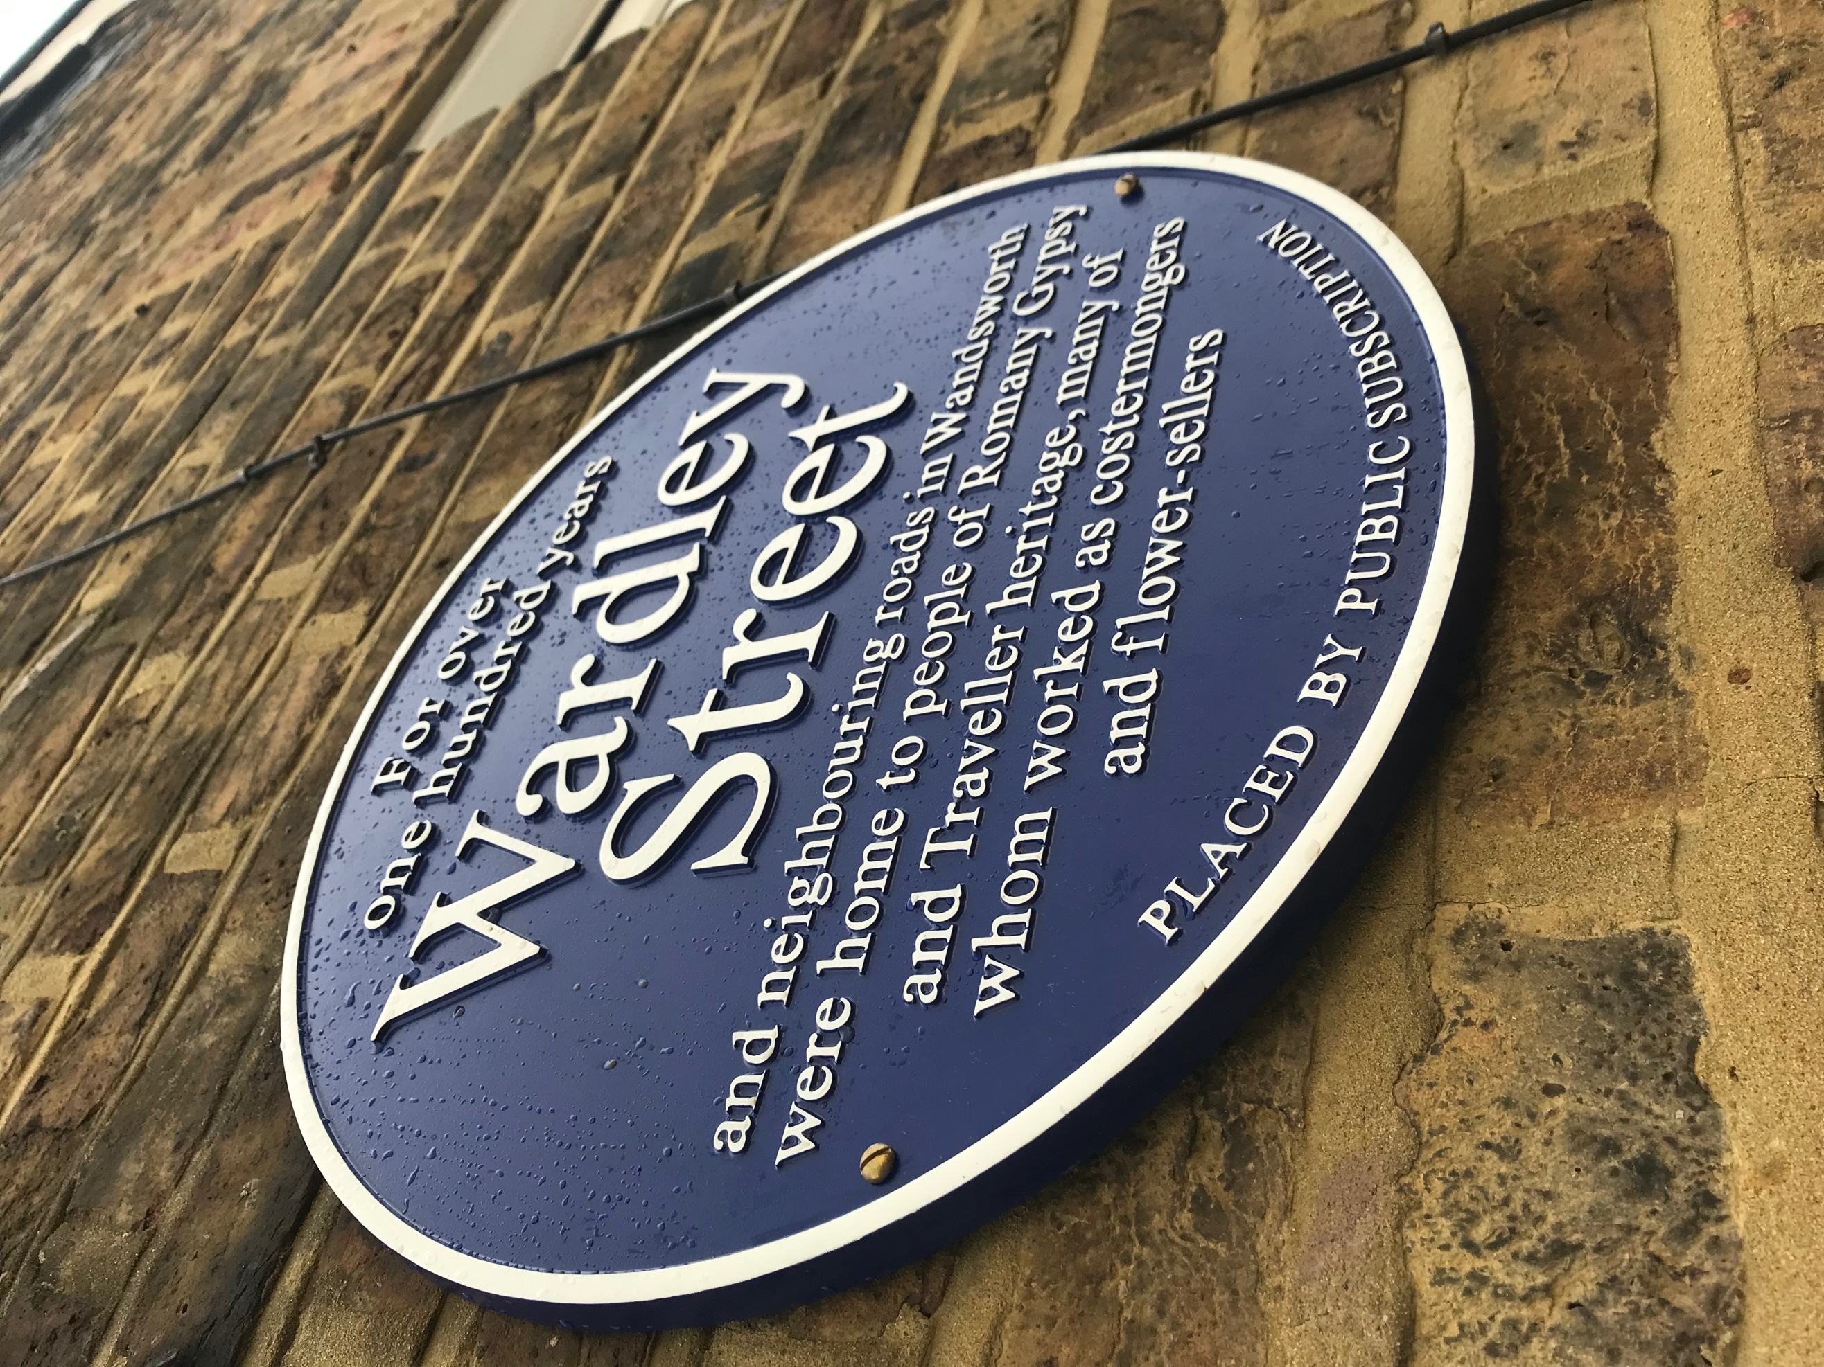
22nd October 2022

A wonderful celebration of the lives and work of the Romany Gypsy and Traveller Communites centred around Wardley street, took place on Saturday the 22nd of October. A guided walk around historical sites of Wandworth was lead by local Historian Geoff Simmons , who navagiate a full crowd around the streets of Earlsfield, detailing the history and heritage of the Romany and Traveller communites who lived and worked there. The walk started at 12pm from St Andrew’s Church community Garden on Garret Lane and followed the leafy streets, visiting Wandsworth Cemetery, then followed the wandle path leading back in to the well know Wardley Street, although much has changed in the road itself, Romany and Traveller people and their traditions are remembered by the families that lived there. The memories of Wardley Street can be heard from many a family member and even from some of its past residents. They came to tell a story or two. Besty Cooper, 76, who lived in a two up two down terraced house in Wardley Street, with her granny, mother, uncles and cousins, who graced us with great stories and memories of her wonderful childhood. She was also joined by two Hilden brothers, who grew up on the same street. It was a wonderful sight to see, all laughing and remembering their shared memories of this much-loved place and all the characters that resided there, which made their childhood a happy one. Betsy Cooper said, “We didn’t have much, but what we had we shared”. Betsy’s Daughter Dee, who has been documenting her mother’s memories of Wardley Street, wrote a poem for the day, that told of them, followed by a few words from the Mayor of Wandsworth, and then a beauitful song ‘Gypsy Boy’from singer, songwriter Florence Joelle. Next came two short but powerful speeches, one from llinca Diaconescu from London Gypsies and Travellers and next Dr Anna Hoare, who invited everyone back to the Anchor Church for refreshments.
The offical unveiling took place at 2.30pm, with an excited crowd counting down, Betsy Cooper and the Hilden brothers, then pulled a banner, saying peace, love and flower to the people down with all their might, uncovering what is thought to be the first Romany and Traveller blue Plaque anywhere. The crowd were happy and Emotional, with pride glowing off the faces of the ex residents that came to take part in such a historic day.
Singer- Songwriter Florence Joelle 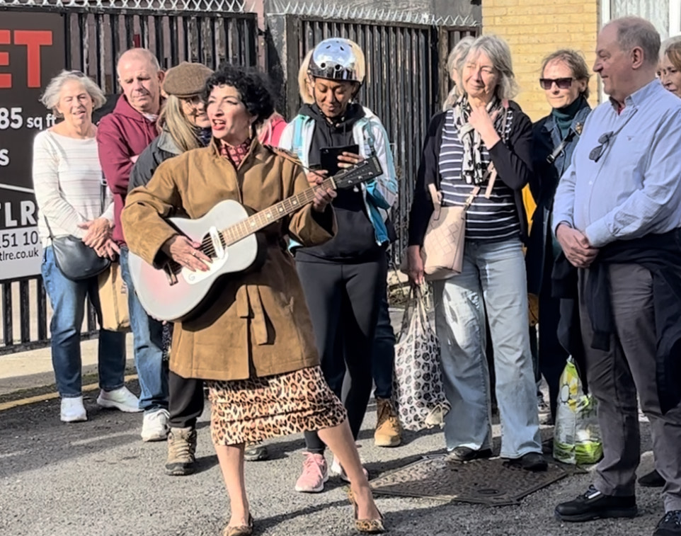

Betsy Cooper
Pictured-Right Wardley Street- Backyard.

Lalage Grundy from Surrey Gypsy, Traveller Communites forum, was there to support the day, along with members from the team, and said “ It was a wonderful day, so many people from the community, lots of people whose families lived in the area, it was so exciting to see this unique plaque unveiled”.
You can follow the wonderful historical work of Geoff Simmons @summerstown182.

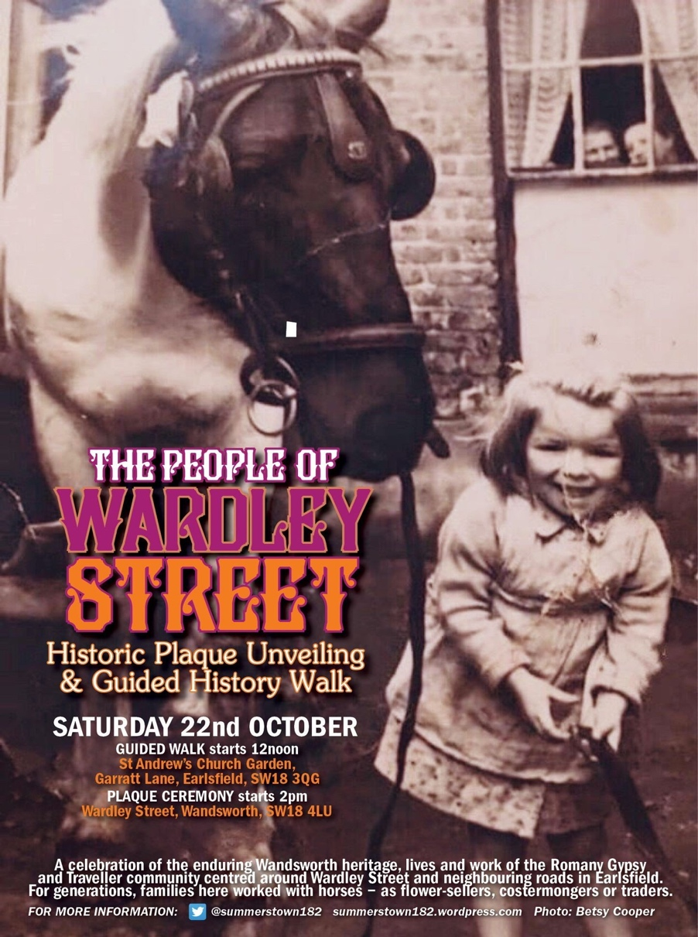

Health
NEWS
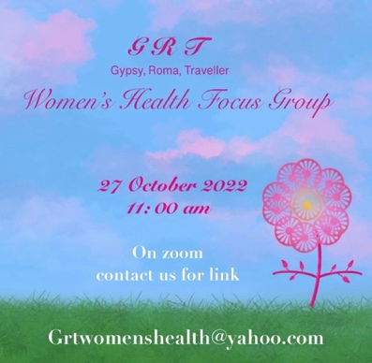

GRT WOMEN’S HEALTH GROUP LAUNCH.

The 27^{th of} October, saw the launch of our first Gypsy, Roma, Traveller, Women’s Health group. It was a successful focus event, made up of ladies from our Communities and GRT trained nurses in surrey. It opened discussions of what is needed to receive successful health care for us all. Discussed in a safe space, it included, one to ones with nurses if in a private breakout room (if required) - via zoom.
Although the project has been started in Surrey, everyone was invited, with the hope of having advocates in other counties, with support from GRT trained nurses up and down the country.
The focus group allowed people to talk about some of the many challenges they faced when trying to, both access and receive medical treatment. Those who attended said, it felt like for the first time they had been heard and looked forward to future meetings and topics that we would cover.
Our next meeting will be held in late January 2023, the topic will be well-being, with a focus on general health day to day and keeping well. As the sessions roll out, we will invite guest speakers and will cover any topics that the group would like to know more about, as well as spending time getting to know each other over a cuppa and sharing ideas to improve a better outcome for our communities when it comes to all our healthcare needs.
This group is supported by NHS Nurses but led by Gypsy, Roma, Traveller Women.
We welcome new members to our Woman’s group, and any guest speakers who work in natural health, fitness/well-being, and from professional organisations that are interested in doing a workshop for our group.
To register for the next meeting or to contact us, please email Grtwomenshealth@yahoo.com
We look forward to hearing from you.

November- Unfortunately due to illness our AGM had to be postponed. A new date will be set for the new year, and we look forward to welcoming you…

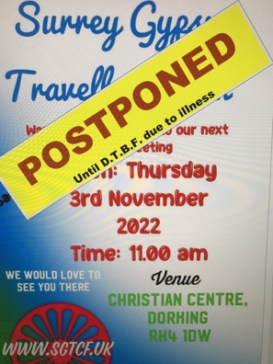
In the meantime, please check out our website on
www.SGTCF.uk or join us for updates on Facebook @SurreySGTCF
We continue to work with 3rd party agencies, including, local councils, community groups, NHS, Mental health organisations, media and more. SGTCF have been serving GRT Communities in Surrey since 1996 and are always keen to hear from you and support where we can.
For all enquires, or your cultural training needs please Email us: surreygypsy@sgtcf.uk
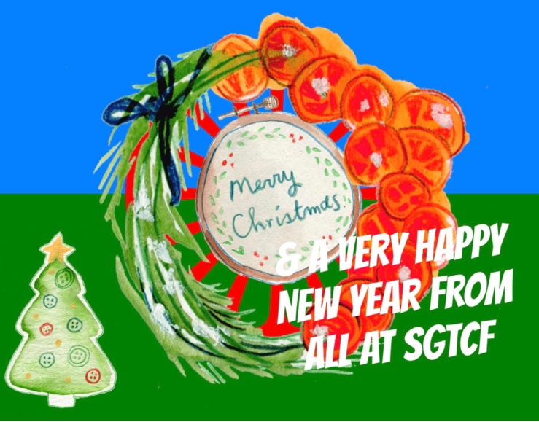
Editor Dee.C. G See you in 2023!

